Successful test cases

1-successfully detecting eyes

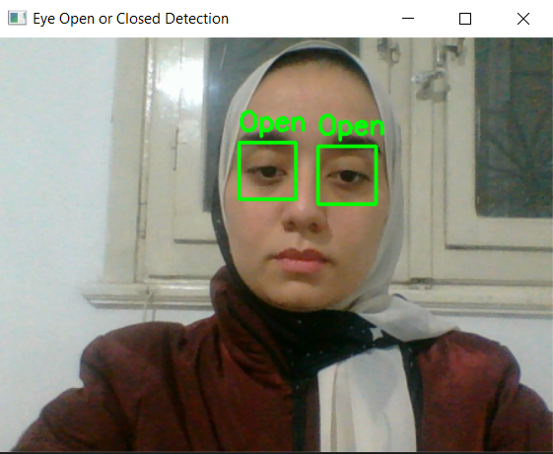

2-another approach successfully detect closed eyes

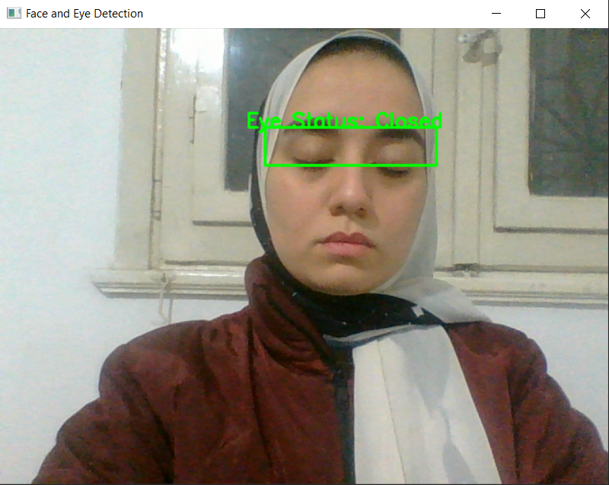

3- another approach where it successfully detected face and two eyes

